Advanced Computer Architecture
HW#1 (Due: 10/16)

- Consider the simple 5-stage pipeline as shown below.
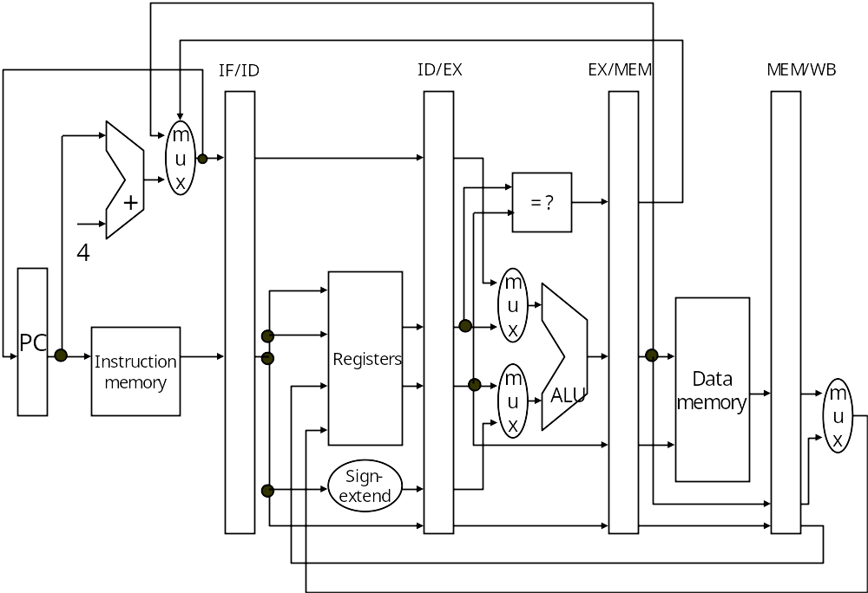

Suppose forwarding technique with interlock is employed. Consider the following instruction sequence.

 | add | x1, x2, x3;
 | add | x5, x6, x1;
 | ld | x4, 20(x8);
 | and | x7, x9, x4;
 | sd | x7, 32(x8);
- Show the timing of the execution in Table I.
Sol:
Table I
Instruction |  |  | Clock Cycle
 |  |  | 1 | 2 | 3 | 4 | 5 | 6 | 7 | 8 | 9 | 10 | 11 | 12 | 13 | 14
 | add | x1, x2, x3; | IF | ID | EX | MEM | WB
 | add | x5, x6, x1; |  | IF | ID | EX | MEM | WB
 | ld | x4, 20(x8); |  |  | IF | ID | EX | MEM | WB
 | and | x7, x9, x4; |  |  |  | IF | ID | stall | EX | MEM | WB
 | sd | x7, 32(x8); |  |  |  |  | IF | stall | ID | EX | MEM | WB

- Show the timing of the execution in Table II.

Table II
Clock  Cycles | Stages
Clock  Cycles | IF | ID | EX | MEM | WB
1 | ADD
2 | ADD | ADD
3 | LD | ADD | ADD
4 | AND | LD | ADD | ADD
5 | SD | AND | LD | ADD | ADD
6 | SD | AND | X | LD | ADD
7 |  | SD | AND | X | LD
8 |  |  | SD | AND | X
9 |  |  |  | SD | AND
10 |  |  |  |  | SD

- Determine the average clocks per instruction (CPI) of the code sequence.
CPI=10/5=2

2.

Consider the following sequence.

 | add | x1, x2, x3;
 | beq | x1, x10, Target1;
 | or | x12, x11, x4;
 | add | x7, x5, x1;
 | sub | x6, x7, x3;
Target1: | add | x1, x6, x5;
 | sd | x1, 64(x6);

Suppose the sequence is executed in the pipeline shown in Problem 1. Assume the branch is taken. Show the timing of the execution in Table III

Table III
Instruction |  |  | Clock Cycle
 |  |  | 1 | 2 | 3 | 4 | 5 | 6 | 7 | 8 | 9 | 10 | 11 | 12 | 13 | 14
 | add | x1, x2, x3; | IF | ID | EX | MEM | WB
 | beq | x1, x10, Target1; |  | IF | ID | EX | MEM | WB
 | or | x12, x11, x4; |  |  | IF | ID | EX | Idle | Idle
 | add | x7, x5, x1; |  |  |  | IF | ID | Idle | Idle | Idle
 | sub | x6, x7, x3; |  |  |  |  | IF | Idle | Idle | Idle | Idle
Target1: | add | x1, x6, x5; |  |  |  |  |  | IF | ID | EX | MEM | WB
 | sd | x1, 64(x6); |  |  |  |  |  |  | IF | ID | EX | MEM | WB

